
FOUNDATIONAL C++ FOR ROBOTICS LAB
Department: Department of Computer Science and Engineering / Robotics
Course Name: Fundamental C++ for Robotics
Course code: - ETCCCPL205
Program Name: Cse (Robotics and AI)
Student Name: Ajitesh Singh Gusain
Roll No.: 2501630014
Faculty Name: Himanshu Kaushik

Unit -2 Assignment: Memory and Data structures

Lab Experiment-6
Analysis of Stack, Static, and Heap Memory Allocation through a C++ Memory Layout Visualization Program
This shows where variables live in your computer's memory.
Code implementation:

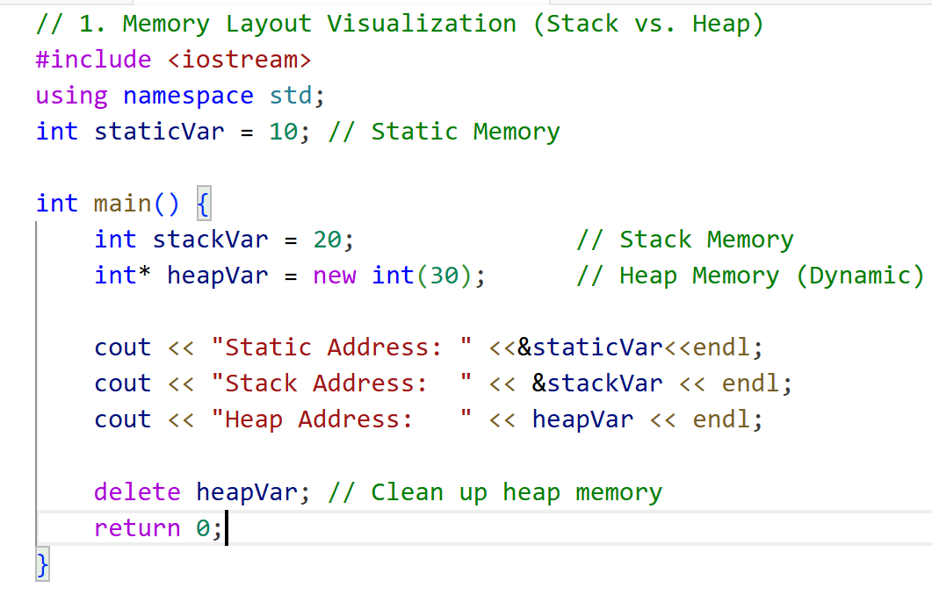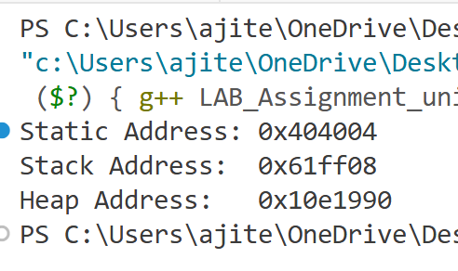

Lab Experiment-7
Analysis of Stack, Static, and Heap Memory Allocation through a C++ Memory Layout Visualization Program
Used when a robot doesn't know how many sensor readings it will take in advance.
Code implementation:

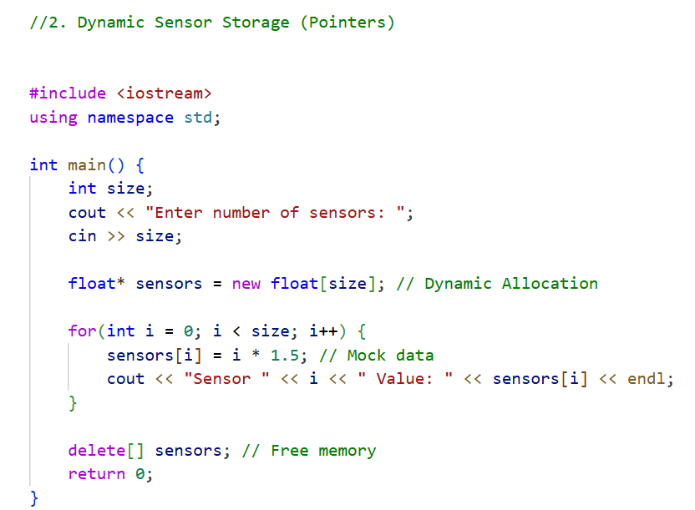

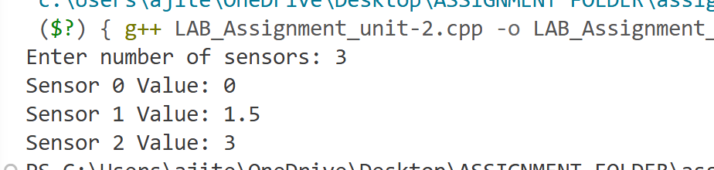

Lab Experiment-8
Implementation of Dynamic Sensor Data Storage and Processing using Pointers and Dynamic Memory Allocation in C++
A vector is a list that grows automatically—perfect for tracking a robot's path.
Code implementation:

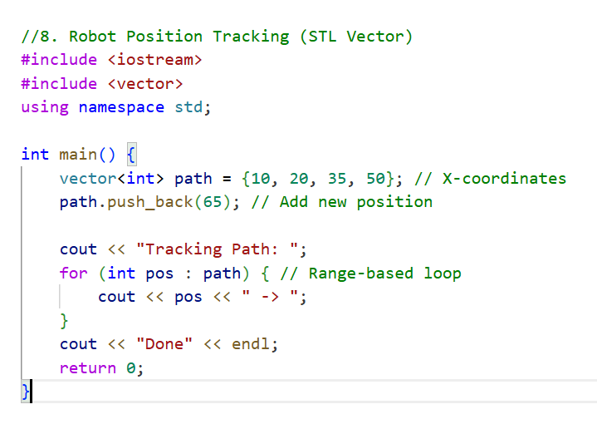
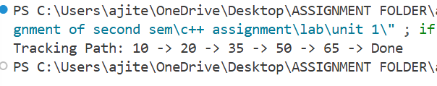

Lab Experiment -9
Command Buffer (STL Queue - FIFO)
"First-In, First-Out" (FIFO). The robot executes commands in the order they were received.
Code implementation:

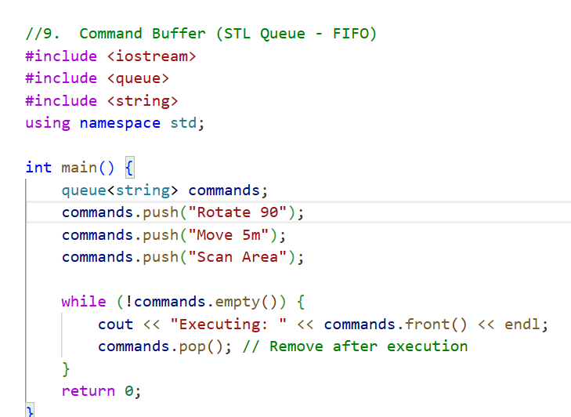
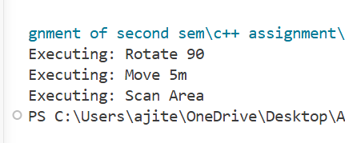

Lab Experiment -10
Safe Sensor Input (Exception Handling)
This prevents the robot "crashing" if it receives impossible data (like a negative distance).
Code implementation:

